Setting up periodic tasks (Jira Automation)

Jira Automation can be used in many ways and can automate nearly everything in Jira. In this document, we described the process of creating periodic tasks and assigning them to a specific person.

Install the add-on in Jira. Go to the project in which we need to create periodic tasks. Go to the Project Settings > Project Automation



Then we get to the Automation screen and see the list of so-called Rules. Rule – predefined automated process. On this Rules page we can create (Create Rule), Turn on/off, Add label.

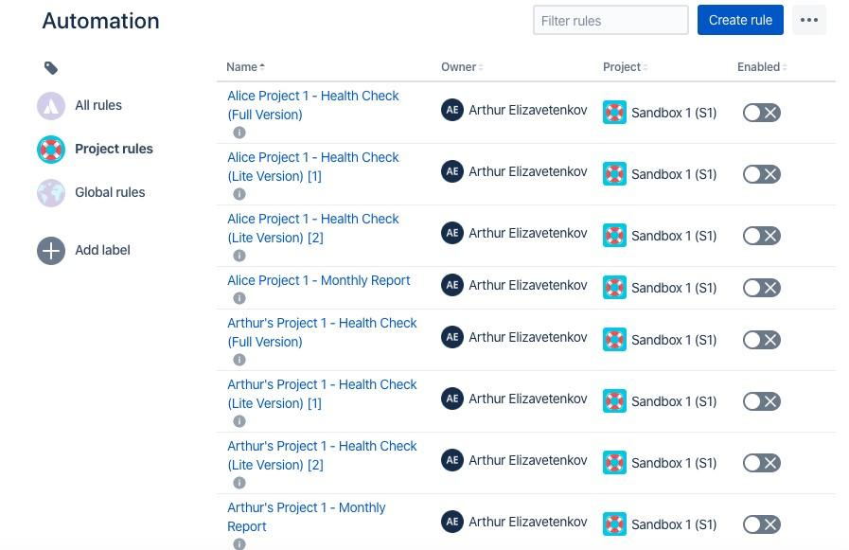

To create automated process click on button - Create Rule and get to the creation window New Trigger – it is a condition that should provoke further action.

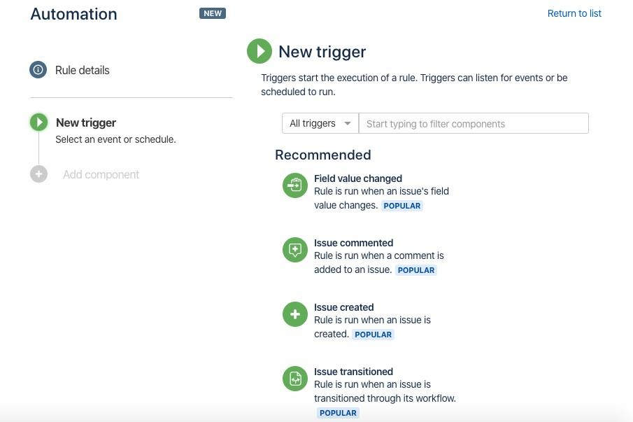

Choose *Scheduled* from the list, Scheduled - schedule a periodic task

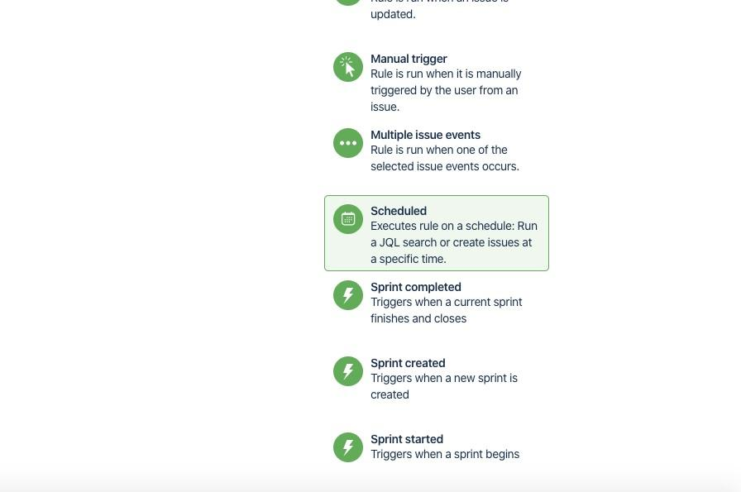

Choose – Cron expression and set the time frame. Cron setup documentation.

On screenshot we set up the cron as follows – 0 0 5 25 * ? – (5 a.m., on the 25th of every month, any day of the week).

Further select “simply run the conditions and actions without providing issues” and click on the Save button.

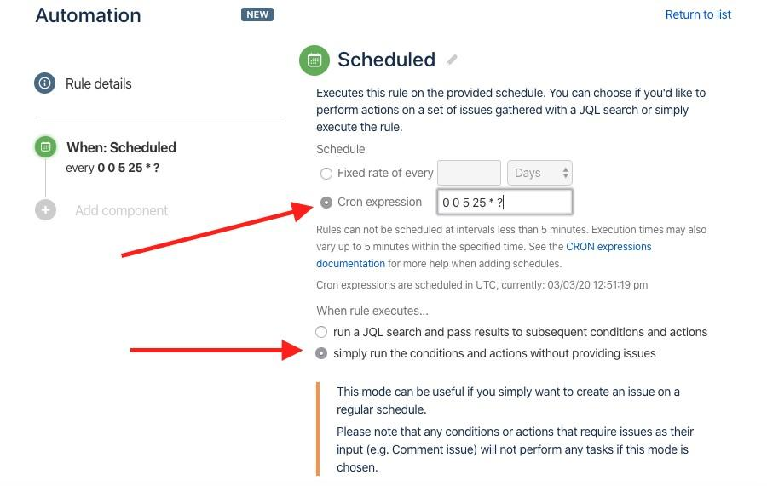

We need to choose the next component, which will perform according to the schedule configured above. Choose New action.

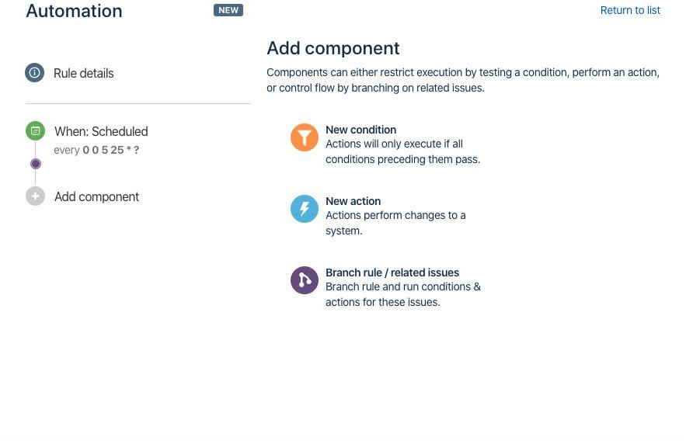

Our next condition will be creation of the task – Create issue.

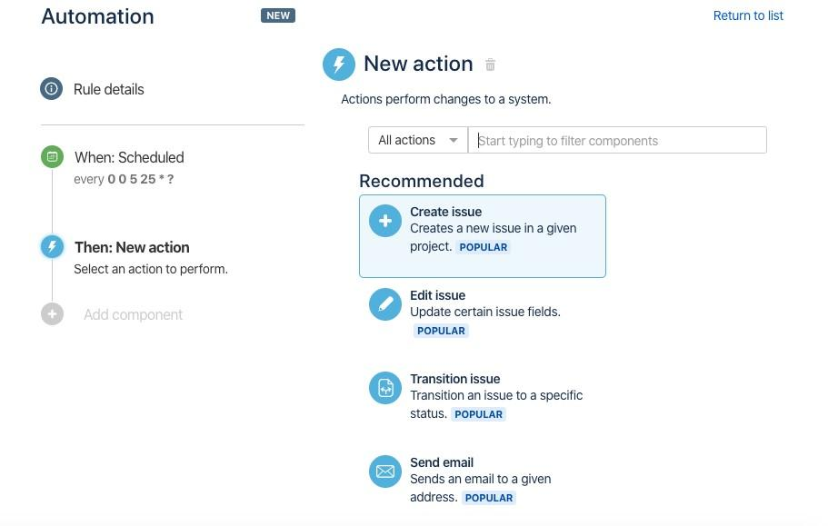

In creation fields we enter the following data:

Project

Issue type Summary

Other fields like Assignee, Components, Due date etc., we add from the list “Choose fields to set…”

Fill in all the necessary fields and click on Save.

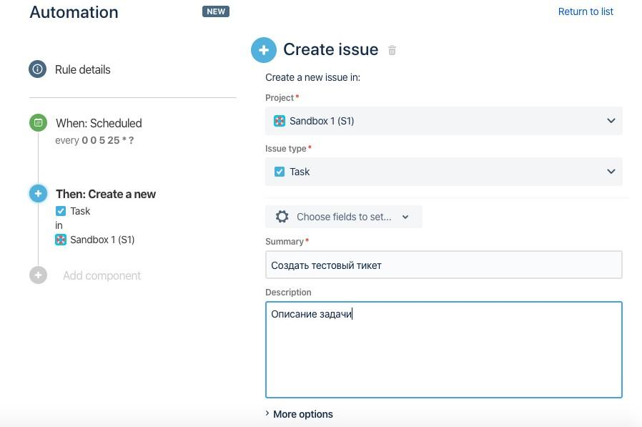

Our automated task is created! All we need to do now is to indicate it’s name in Name your automation field and click on Turn it on.

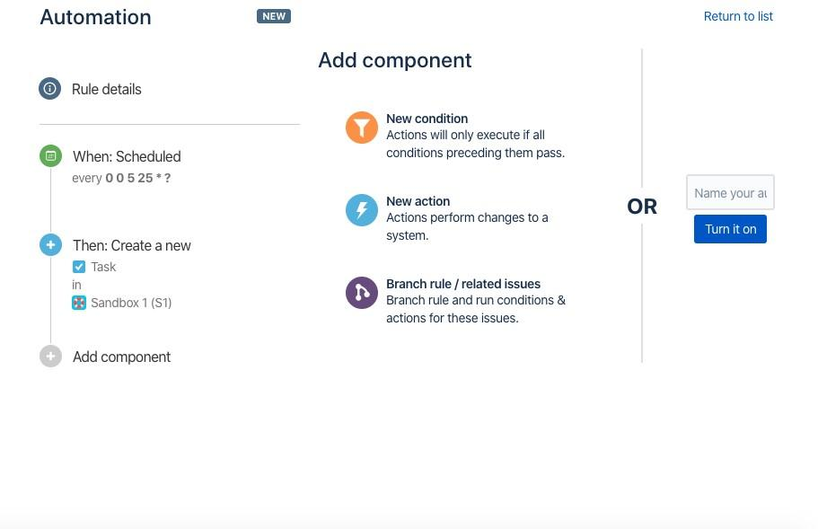

Further we return to the automation list and see the created Rule with New tag.

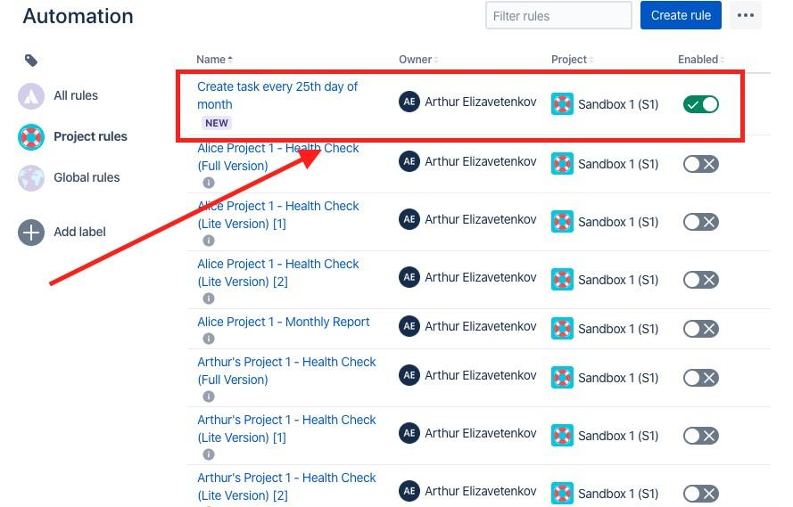

We've just successfully created the simplest type of automation in Jira - a periodic task.



### Additionally

When creating a monthly task, you can set a ***value?*** by which the name of the month will be automatically set in the Summary task.

It is necessary to add ‘ ‘ ‘{{now.format(“MMMM”)}} ‘ ‘ ‘ in the task’s title:

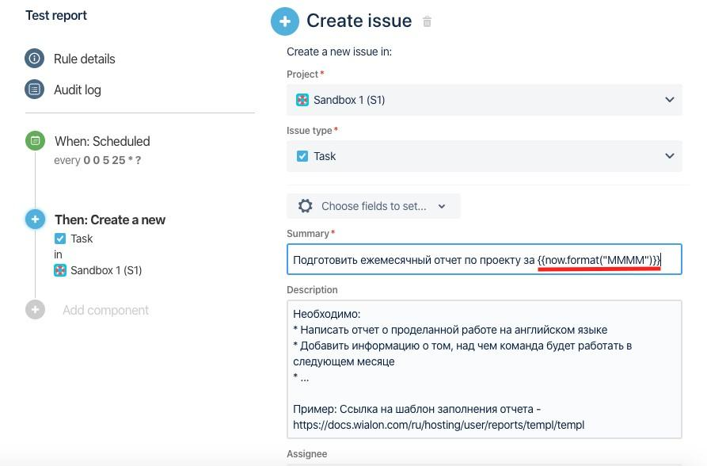

The created task will look the following way.

